Our Partnership Proposals

Partnership in the Gospel

Grace to you and peace from God our Father
and the Lord Jesus Christ.

I thank my God in all my remembrance of you,
always in every prayer of mine for you all
making my prayer with joy,
thankful for your partnership in the gospel
from the first day until now.

And I am sure that he who began a good work in you
will bring it to completion at the day of Jesus Christ.

Philippians 1:2-6

Prayer resources have been developed to accompany this stage of our Forward Together in Hope journey. They are available from the resources section of the website and are designed to be customised for use within parishes and emerging partnerships.

Our Partnership Proposals

For almost two years we have all been exploring what it means to be a disciple of Jesus within a viable and flourishing community. In the short time between now and the beginning of Advent we need to draw upon our exploration and look very practically at how resources can be shared and leadership developed to enable our communities to flourish into the future. Every parishioner has been asked to contribute to this by thinking and praying about partnership and offering their practical suggestions through the tear-off slip from the Imagine new ways… leaflet.
This document, Our Partnership Proposals, requests information from a group of parishes about their initial proposals for developing new partnership arrangements. Please read this in conjunction with the booklet From Parish to Partnership published in June this year which sets out detailed information about these partnerships and their benefits. In it we are reminded that Pope Francis speaks of ‘parish’ as ‘not an outdated institution precisely because it possesses great flexibility; it can assume quite different contours depending on the openness and missionary creativity of the pastor and community’. We now have a real opportunity to follow this call to be flexible, open, creative and missionary as we travel together on the next stage of our journey.
Electronic versions of both of these documents are available within the resources section of the Forward Together in Hope website at www.hope.rcdhn.org.uk.
One completed document for each proposed partnership should be returned electronically to hope@diocesehn.org.uk by mid-day on the First Sunday of Advent (27th November) at the latest. It is essential that all areas adhere to this deadline to ensure that their proposals are taken into account within the diocesan-wide proposals that will be developed as a next stage.
We welcome completed documents ahead of this date. Please copy your proposals to the Dean(s) with responsibility for the parishes in the proposed partnership.
All information received by 27th November will be worked with during December to produce the first draft of a ‘Flexible Plan’ for consideration by Bishop Séamus and the Diocesan Board of Directors at their residential meeting. Prior to that meeting we may need to communicate with the contact person for the proposed partnership (usually the Dean or his nominee) to clarify particular issues or to ask for further details.
We are conscious that in parts of the diocese all of this is very new and that some proposals presented will be very much an outline. Other areas may well be able to go into a lot more detail. In all cases it is important to remember that the documents submitted at the end of November represent initial proposals. Once they are all received, these proposals have to be brought together to arrive at a position that works well across the diocese as a whole. While this is likely to mean that some proposals may not be accepted in their entirety, all thoughts and ideas received by the deadline will be brought to bear on the recommendations put forward to Bishop Séamus and the Diocesan Board.
When Bishop Séamus has considered everything, his decisions will be communicated widely across the diocese. Partnership arrangements will then be firmed up and each area asked to commence detailed planning and implementation.
For advice about completing this document, or for any other queries, please feel free to contact the Forward Together in Hope team by e-mail at hope@diocesehn.org.uk or by telephone on 0191 243 3304.
Thank you for everything that you are doing to make Forward Together in Hope a success.

Section 1: Details of the Proposed Partnership
The parish is not an outdated institution precisely because it possesses great flexibility;
it can assume quite different contours…
Pope Francis - Evangelii Gaudium

(Please refer to Section 2.1 on Page 6 of ‘From Parish to Partnership’)

  - Please list the parishes that you envisage being involved in the proposed partnership.
(Please extend this table if necessary)

Parish Name | Location | Priest(s) | Deacon(s) | Mass Attendance*
TOTAL MASS ATTENDANCE

* Please include the average Mass attendance figure for each parish as reported in October 2015. (We are aware that there are sometimes seasonal variations in Mass attendance).
1.2 Why is this grouping seen as the most appropriate for your area?
Please provide as much information as you can in presenting a rationale for the proposed partnership arrangement. You may wish to consider, for example, complementary skills/experience, historical connections, distances, existing joint activity, finances, numbers attending Mass etc.

1.3 What issues might get in the way of effective joint working in this partnership area and how might these be minimised?
Issue | Minimising the impact

1.4 Were there any alternative partnership combinations that were seriously considered as part of your deliberations?
Yes/No (Please delete as appropriate)
If ‘Yes’, please describe these arrangements, their advantages and disadvantages and why they are less appropriate than your preferred option.

There is a variety of gifts but always the same Spirit; there are all sorts of service to be done,
but always to the same Lord,
working in all sorts of different ways
in all sorts of people.
1 Cor. 12:4-5

Section 2: New Ways of Working Together
(Please refer to Sections 2.2 and 2.3 on Page 6 of ‘From Parish to Partnership’)

2.1 What leadership/co-ordination arrangements are proposed for the partnership area?
Please think about possible leadership structures, roles and responsibilities and associated training and development etc.

2.2 What initial areas of joint working are proposed for the partnership area?
Please identify the main areas that are seen as initial priorities for joint working across the proposed partnership. It is important to share the ‘Observations on Parish Questionnaires’ and draw upon these.

2.3 What approaches will you use to ensure plans and developments are communicated well across the proposed partnership area?
Taking into account the expected decline in the number of priests and people over time you may wish to think about this in relation to the short term (1-2 years), medium term (3-5 years) and long term (up to 2030).

- Short term:

- Medium term:

- Long term:

2.4 We are seeking to ensure that our worshipping communities nurture disciples to witness to Jesus in our world. What resources will be necessary to ensure this takes place and is co-ordinated across the proposed partnership?
Note: People often think about administrative support – but please think more widely about how the various facets of the partnership (e.g. Young People, Outreach, Lay Leadership, Spiritual Development etc.) could benefit from co-ordinated voluntary or paid support and what training might be required.

2.5 What proposals / initial thoughts are there for new ways of working within the proposed partnership area?
Please remember that these new partnerships are not simply groupings of a number of current parishes with their existing arrangements and structures - they offer the opportunity to look at things differently and innovatively to ensure viable and flourishing communities. You may wish to consider, for example, bringing together existing groups/creating new groups, committees and Councils and strengthening links with schools. In some areas it may be desirable for the parishes within a partnership area to merge over time.
Once again, conscious of the gradually reducing number of priests and people, you may wish to think about this in relation to the short term (1-2 years), medium term (3-5 years) and long term (up to 2030).

- Short term:

- Medium term:

- Long term:

Section 3: Facilities
I will be looking carefully and seriously at any necessary restructuring, including: the closure of some of our church buildings; use of our building for other purposes and the need to reduce the number of Masses being celebrated.
Bishop Séamus - July 2014

(Please refer to Section 2.4 on Page 7 of ‘From Parish to Partnership’)

3.1 Please list each of the churches in your proposed partnership along with their maximum capacity and details of any existing issues/future plans that might have a bearing on their use.
Church Name | Location | Max. Capacity | Existing Issues/Future Plans

3.2 Please list any other buildings (e.g. schools) that are currently used, or which could be used, for worship. Please feel free to add any notes to explain your thinking.

Venue | Parish/Location | Max. Capacity | Used Now (N) /Could Use (C)  Include any notes here
3.3 What thoughts are there about the use of the current places of worship in the proposed partnership area?
If we have around 50 active priests in the diocese in 2030 it is inevitable that Mass will be celebrated in fewer churches and less frequently. Please present your thoughts, however tentative, about the places of worship currently in use across the proposed partnership area and what the future arrangements might look like. In time it will be important to consider which buildings will be retained for worship (not necessarily for the celebration of Mass) and which might close or be used for other purposes.

3.4 Are there any thoughts about where the priest(s) would reside in the partnership area?

Section 4: Next Steps
But you are a chosen race, a royal priesthood, a consecrated nation, a people set apart to sing the praises of God.
2 Pet. 9

(Please refer to Section 2.5 on Page 7 of ‘From Parish to Partnership’)

4.1 Should your partnership proposals be accepted, please indicate what the key next steps would be for your area. Please add timescales where possible.

4.2 What support would be most useful to you from other parishes/partnerships/the diocese in achieving the next stages of your proposed partnership?

4.3 Please provide any additional information you feel we should be aware of when considering your proposals.

4.4 What questions/concerns do you have about the next stages of the process of moving to partnership arrangements across the diocese?
Section 5: The Consultation Process
I thank my God in all my remembrance of you, always in every prayer of mine for you all making my prayer with joy, thankful for your partnership in the gospel from the first day until now. Philippians 1:5

a) Partnership View
5.1 Please describe the process undertaken to arrive at your outline partnership proposals.

5.2 Were the individual Parish Observations and Profiles shared with all parishes in the proposed partnership as part of this process?
Yes/No
Comments:

5.3 Please list any key meetings/activities that have taken place along with numbers attending.
Date | Venue | Purpose of meeting/activity | Numbers attending/  participating

5.4 Please list any specific groups or committees that have been consulted.

5.5 How widely has this completed document been circulated prior to submission? Please provide details.

b) Parish View
We are keen to understand the level of awareness and consensus within individual parish communities in relation to the proposed partnership arrangements. To this end, please ensure that each parish in the proposed partnership completes the questions below. If parishes wish to, they can provide a short (maximum of 250 words) perspective on the proposed partnership. Please enter the name and role of the person completing this on behalf of the parish.
Note: Please copy and paste this section for each parish in the proposed partnership.
Parish | Name of Person | Role
Level of knowledge of proposals - Very High/High/Medium/Low/Very Low
Any comment:

Level of consensus with proposals - Very High/High/Medium/Low/Very Low
Any Comment:

Parish perspective (250 Words or less)

Contact Details
We may need to get in touch with you for additional information about your proposals. Please provide contact information for a main contact person and an alternate (should the main contact person not be available). We would recommend that the main contact is the Dean with responsibility for the majority of parishes within the proposed partnership (or his nominee).
 | Main Contact | Alternate contact
Name
Role
Address
Telephone
E-mail

Please return your proposals to hope@diocesehn.org.uk by mid-day on Sunday 27th November 2016 and copy these to the Dean(s) with responsibility for parishes in your proposed partnership.
Thank you for completing this document and for all you are doing to support Forward Together in Hope.
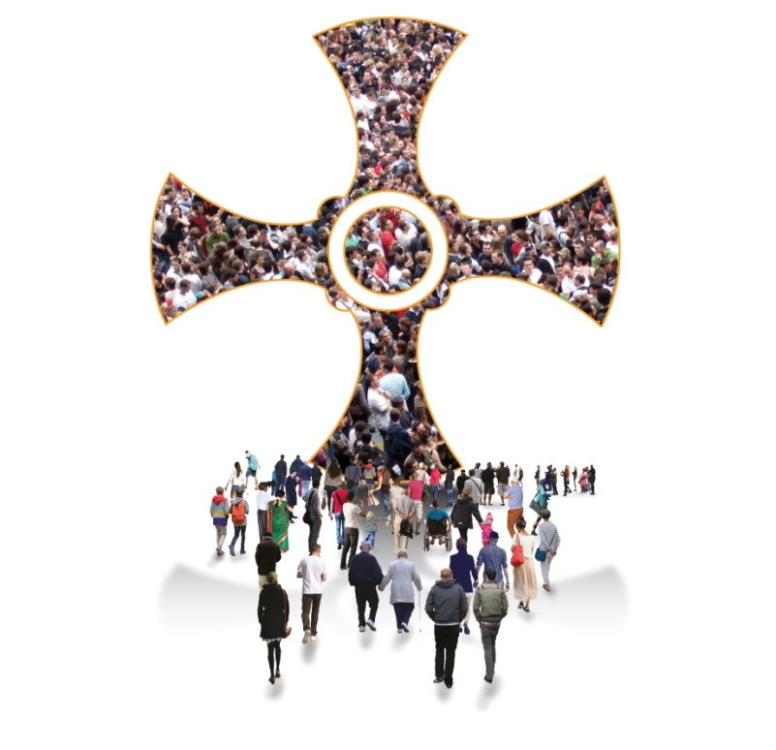

Diocese of Hexham and Newcastle, Department for Development and Renewal
Tel: (0191) 243 3304 E-mail: hope@diocesehn.org.uk Web: www.hope.rcdhn.org.uk

©Diocese of Hexham and Newcastle – September 2016
Also available in other formats

